# FMC Diagram Research

Purpose of Fundamental Modelling Concepts (FMC)

FMC provides a framework for the illustration of software intensive systems (Home of Fundamental Modelling Concepts, 2003). It is based on exact terminology and is supported to notation (Home of Fundamental Modelling Concepts, 2003). FMC allows developers, software engineers, software architects and more to effectively communicate how their software works on a high level which enables those who do not have a deep level of understanding about software engineering (Home of Fundamental Modelling Concepts, 2003). It also allows quick communication. running through and interpreting code takes time, using FMC allows quick understanding of how a piece of software is implemented and works (Home of Fundamental Modelling Concepts, 2003).

|  |  |  |
| --- | --- | --- |
| **Basic Elements** (Home of Fundamental Modelling Concepts, 2003) | | |
| http://www.fmc-modeling.org/images/notation_reference/compositional/agent.gif | *active system component: agent, human agent* | Serves a well-defined purpose and therefore has access to adjacent passive system components and only those may be connected to it.  A human agent is an active system component exactly like an agent but the only difference that it depicts a human.  *(Note: nouns should be used for identifier "A")* |
| http://www.fmc-modeling.org/images/notation_reference/compositional/location.gif | *passive system component (location):  storage, channel* | A Storage is used by agents to store data.  A channel is used for communication purposes between at least two active system components.  *(Note: channels are usually depicted as smaller circles but may also vary like the graphical representation of storage places)* |
| http://www.fmc-modeling.org/images/notation_reference/compositional/access_type.gif | *access type* | Directed and undirected edges represent the kind of access an active system component has to a passive system component. The types of access are read access, write access and a combination of both.  *(Note: usually undirected edges depicting read/write access are used on channels whereas two directed edges also depicting read/write access are used on storages)* |
| **Common Structures** | | |
| http://www.fmc-modeling.org/images/notation_reference/compositional/read_access.gif | *read access* | Agent A has read access to storage S. |
| http://www.fmc-modeling.org/images/notation_reference/compositional/write_access.gif | *write access* | Agent A has write access to storage S. In case of writing all information stored in S is overwritten. |
| http://www.fmc-modeling.org/images/notation_reference/compositional/modifying_access.gif | *read / write access (modifying access)* | Agent A has modifying access to storage S. That means that some particular information of S can be changed. |
| http://www.fmc-modeling.org/images/notation_reference/compositional/unidirectional_channel.gif | *unidirectional communication channel* | Information can only be passed from agent A1 to agent A2. |
| http://www.fmc-modeling.org/images/notation_reference/compositional/bidirectional_channel.gif | *bidirectional communication channel* | Information can be exchanged in both directions (from agent A1 to agent A2 and vice versa). |
| http://www.fmc-modeling.org/images/notation_reference/compositional/request-response_channel.gif | *request / response communication channel (detailed and abbreviation)* | Agent A1 can request information from agent A2 which in turn responds (e.g. function calls or http request/responses).  Because it is very common, the lower figure shows an abbreviation of the request/response channel. |
| http://www.fmc-modeling.org/images/notation_reference/compositional/shared_storage.gif | *shared storage* | Agent A1 and agent A2 can communicate via the shared storage S much like bidirectional communication channels. |

|  |  |  |
| --- | --- | --- |
| **Basic Elements** | | |
| http://www.fmc-modeling.org/images/notation_reference/dynamic/transition.gif | *transition* | Stands for an operation, an event or an activity.  *(Note: verb should be used for identifier "T")* |
| http://www.fmc-modeling.org/images/notation_reference/dynamic/place.gif | *unmarked and marked place* | A place represents a control state or an additional condition. It may be marked, i.e. it holds a token.  *(Note: here capacity = 1, i.e. a place cannot hold more than one token at the same time)* |
| http://www.fmc-modeling.org/images/notation_reference/dynamic/directed_arc.gif | *directed arc* | Connects a place and a transition.  *(Note: here arc weight = 1, i.e. exactly one token will be consumed or produced when the connected transition fires)* |
| **Further Elements** | | |
| http://www.fmc-modeling.org/images/notation_reference/dynamic/NOP.gif | *NOP* | A transition meaning No Operation.  *(Note: often used to preserve the bipartitions)* |
| http://www.fmc-modeling.org/images/notation_reference/dynamic/swinlane_divider.gif | *swimlane divider* | Distinguishes competences of agents. |

These are all the basic elements required to create an FMC diagram. These elements are used together to create a diagram that accurately depicts a high level model for the chosen software system. It will be important to note how read and write access functions as note depicting it correctly can make the entire model invalid. Some elements will not be used for the FMC model as they do not apply to the software system being developed. These include “NOP” or No Operation transition. This is because all the transitions in the FMC model that will be developed will have a purpose nor will the model have any bipartitions. Swim lanes will not be used either as all the agents access the system through the same methods and just adds unneeded complexity to a model specially designed to be viewed by those who don’t understand the underpinnings of the software system.

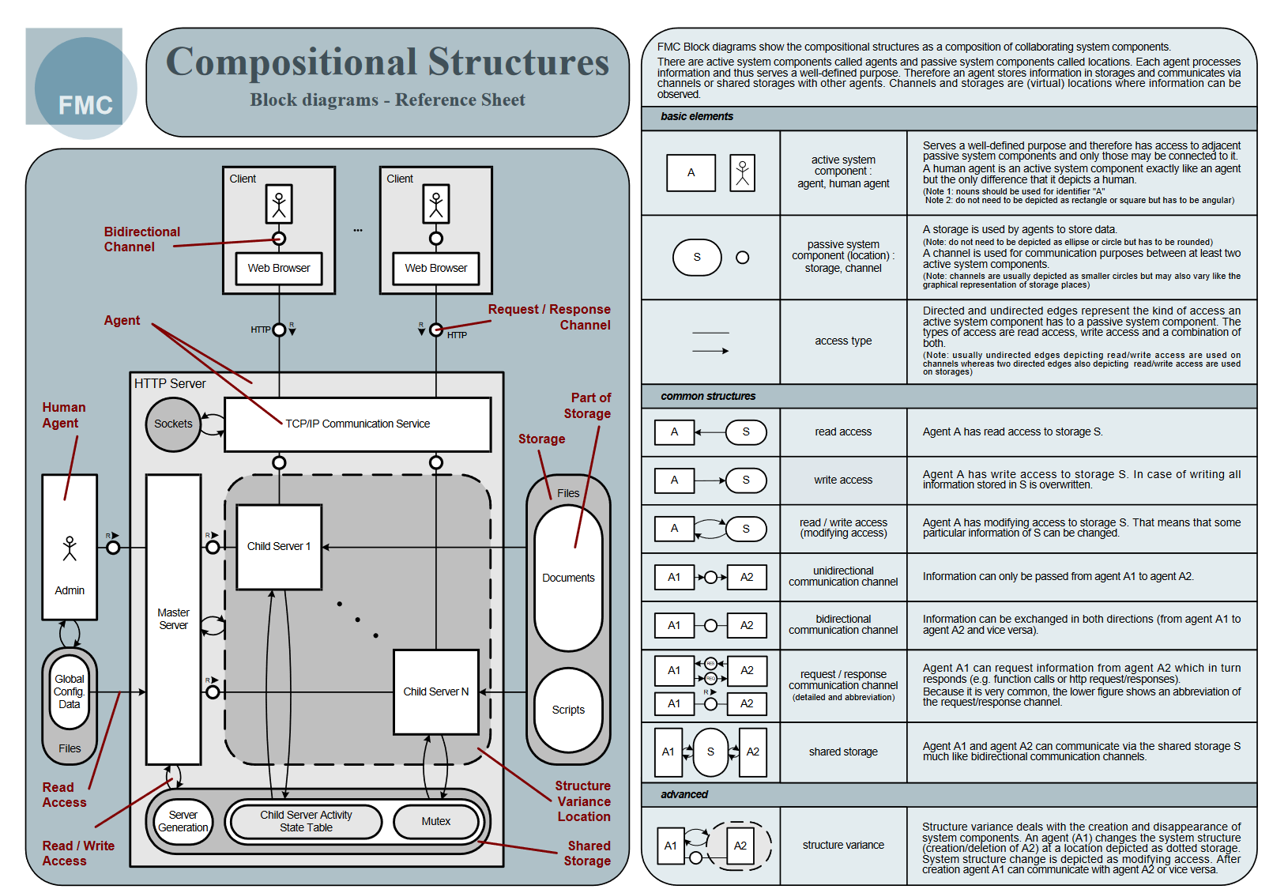 (Home of Fundamental Modelling Concepts, 2003)

Here is a model that will be used as a reference for creating the FMC model for our system. It details how the elements work together and why specific FMC elements are used where.

# Bibliography

Home of Fundamental Modelling Concepts, 2003. *Notation Reference.* [Online]   
Available at: http://www.fmc-modeling.org/notation_reference  
[Accessed August 2016].